Smallest Estimated Transmission Time of the Packet (SET)

To begin, we arrange all of the packets in a non-decreasing sequence based on the projected amount of time it takes for each packet to transfer. After that, the first packet will be booked on the available router, and this process will continue until there are no more packets to schedule.

Algorithm:

Define Array → packets (j)

Category (i)

Router (R1)

Router (R2)

Time estimation for Packets (tj)

Timeout on Router 1 (${To}_{1}$)

Timeout on Router 2 (${To}_{2}$)

Procedure For each packet (j):

1: Sort packets in non-decreasing order based on their estimated transmission time (tj).

2: Initialize timeout ${To}_{1}$ and ${To}_{2}$ for Routers R1 and R2 respectively.

3: Initialize empty queues for router R1 and R2.

Loop

4: For each packet j from 0 to length of packets -1:

If ${To}_{1}$ ≤ ${To}_{2}$

Available Router = R1

else

Available Router = R2

If category[j] = category [least available router [0]]

Add j to the front of least available router’s queue

else

Add j to the back of least available router’s queue

else

Add j to the back of least available router’s queue.

Update timeouts ${To}_{1}$ and ${To}_{2}$ based on the current queue lengths of R1 and R2.

5: Repeat step 4 until the processing of all the packets.

Example:

1: Sort packets based on their estimated transmission time (tj).

Sorted packets:

j: [8, 10, 5, 9, 4, 6, 7, 1, 3, 2]

i: [4, 1, 3, 4, 4, 4, 1, 1, 3, 2]

tj: [5, 6, 9, 11, 11, 12, 16, 14, 17, 12]

2: Initialize timeouts To1 = 5 and To2 = 3, and empty queues for R1 and R2.

3: Packet Processing:

At first iteration: Packet 8 is selected and added to R2.

R1: []

R2: [8,]

At second iteration: Packet 10 is selected and added to R2.

R1: []

R2: [8,10]

At third iteration: Packet 5 is selected and added to R1.

R1: [5]

R2: [8, 10]

At fourth iteration: Packet 9 is selected and added to R2.

R1: [5]

R2: [8, 10,9]

At fifth iteration: Packet 4 is selected and added to R2.

R1: [5]

R2: [8, 10, 9, 4]

At sixth iteration: Packet 6 is selected and added to R1.

R1: [5,6]

R2: [8, 10, 9, 4]

At seventh iteration: Packet 7 is selected and added to R1.

R1: [5,6,7]

R2: [8, 10, 9, 4]

At eigth iteration: Packet 1 is selected and added to R2.

R1: [5,6,7]

R2: [8, 10, 9, 4,1]

At nine iteration: Packet 3 is selected and added to R2.

R1: [5,6,7]

R2: [8, 10, 9, 4,1,3]

At tenth iteration: Packet 2 is selected and added to R2.

R1: [5, 6, 7]

R2: [8, 10, 9, 4, 1, 3, 2]

4: All packets are processed.

There is a value of 57 for the completion time, and the sequences of the packets that are flowing through the two routers are as follows:   
  
R1 {5, 6, 7}.   
R2 {8, 10, 9, 4, 1, 3, 2}   
This solution is accomplished by the utilization of the ESE algorithm, which helps to optimize the selection of routers based on timeout testing. Due to the fact that it optimizes router selection, the ESE algorithm generates a solution that is superior to the SET heuristic.

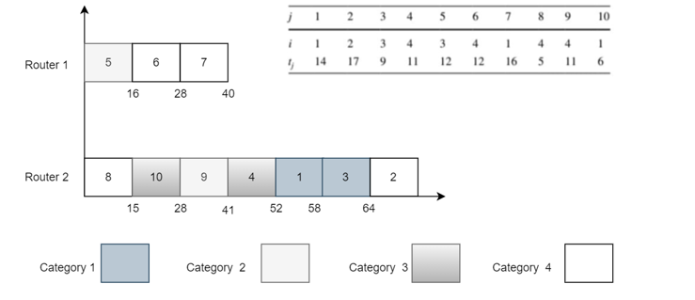

This picture illustrates the packet queues and timeouts (TO1 and TO2) that are present on Routers R1 and R2.   
  
R1 and R2 routers begin with a blank state.   
In accordance with the timeout values, the router places packets in a queue as they are processed.   
The processing order is used to sort each individual packet.   
For the purpose of this illustration, the completion time after processing all of the packets is 57.   
The ESE algorithm and timeout options are utilized in this illustration to provide an explanation of router packet scheduling.